Multiple-choice section

|  |  |  |  |  |  |  |  |  |  |
| --- | --- | --- | --- | --- | --- | --- | --- | --- | --- |
| Question | 1 | 2 | 3 | 4 | 5 | 6 | 7 | 8 | 9 |
| Answer | A | D | D | C | A | D | C | C | B |

Question 1 [6.1]

**A**

*q* and *w* are in corresponding positions.

Question 2 [6.1]

**D**

Supplementary angles add to 180°.

180 – 105 = 75°

Question 3 [6.1]

**D**

*p* =110° (vertically opposite)

*u* =70° (co-interior)

*v* =110° (corresponding)

Question 4 [6.2]

**C**

The hypotenuse is not given in this triangle so the right angle is just an included angle between the two pairs of equal sides. Therefore, the congruency test is SAS.

Question 5 [6.4,6.5]

**A**



Question 6 [6.1,6.3]

**D**

co-interior angles of parallel lines

180 – 120 = 60°

Question 7 [6.3]

**C**

Polygon angle sum is given by:

*S* = 180(*n* – 2)

A hexagon has six sides so *n* = 6

*S* = 180(*n* – 2)

*S* = 180(6 – 2)

*S* = 180  4

 *S* = 720

Question 8 [6.5]

**D**

scale factor is = = 

Question 9 [6.3]

**B**

Polygon angle sum is given by: *S* = 180(*n* – 2)

The sum of the angles of a pentagon is:

*S* = 180 (*n* – 2)

*S* = 180 × 3

*S* = 540°

A pentagon has 5 sides so the size of one angle is: 540 ÷ 5 = 108°

Multiple-choice total marks: 9

Short answer section

Question 10 3 marks [6.1,6.2,6.5]

**(a)** Two triangles are congruentif they are the same shape and the same size.

**(b)** Triangles that are the same shape but not the same size are similar*.*

**(c)** Alternate angles are found on the opposite sides of a transversal that crosses a pair of parallel lines.

Question 11 3 marks [6.1]

|  |  |  |
| --- | --- | --- |
| Angle | Value | Reason |
| *a* | 120° | Supplementary angle to 60° (180 – 60 = 120°) |
| *b* | 60° | Corresponding angle to 60° |
| *c* | 120° | Corresponding angle to *a* |
| *d* | 120° | Vertically opposite angle to *a* |
| *e* | 60° | Vertically opposite angle to 60° |
| *f* | 120° | Alternate angle to *a* |
| *g* | 60° | Vertically opposite angle to *b* |

Question 12 6 marks [6.3]

|  |  |  |  |  |  |  |
| --- | --- | --- | --- | --- | --- | --- |
| **(a)** Triangle  *x* + 90 + 28 = 180  *x* + 118 = 180  *x* = 180 – 118  *x* = 62°° |  |  | **(b)** Trapezium  2*a* + 65 + 32 + 63 = 360  2*a* + 160 = 360  2*a* = 360 – 160  2*a* = 200  *a* = 100° |  |  |  |
| **(c)** Quadrilateral  3*x* + 4*x* + 2*x* + 90° = 360° (sum of angles of a quadrilateral is 360°)  9*x* = 360° – 90°  9*x* = 270°  *x* = 30° |  |  | **(d)** Parallelogram  2*y* + 3*y* = 180°  (co-interior angles in parallel lines add up to 180°)  5*y* = 180°  *y* = 36°  *z* = 2*y*°  (opposite angles of a parallelogram are equal)  *z* = 72° |  |  |  |

Question 13 3 marks [6.5]

∠*ACB* = 20°

∠*EDF* = 40°

In ∆*ABC* and ∆*DEF*

∠*ABC* = ∠*DEF* (both 120°)

∠*ACB* = ∠*DFE* (both 20°)

∠*BAC* = ∠*EDF* (both 40°)

∴ ∆*ABC* ~ ∆*DEF* (AAA)

Question 14 2 marks [6.2]

The hypotenuse in each triangle = 6 mm

Each triangle has another side equal to 4 mm.

Each triangle has a right angle.

The triangles are congruent using the RHS test.

Question 15 2 marks [6.7]

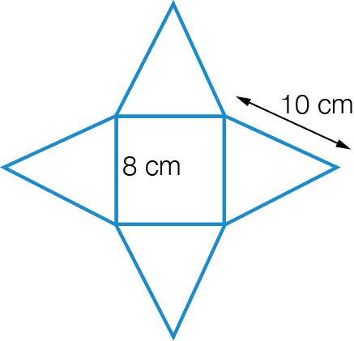

Question 16 2 marks [6.6]

The triangles are similar because they each have a right angle, and a pair of vertically opposite angles are equal.



Question 17 3 marks [6.4]

Side of small pentagon = 1 cm

Side of large pentagon = 1.5 cm

Scale factor = 1.5 ÷ 1 = 1.5

Question 18 3 marks [6.1]

2*e* + 3*e* + 50° = 180° (angle sum of triangle is 180°)

5*e* + 50° = 180°

5*e* = 130°

*e* = 130° ÷ 5 = 26°

*d* = 3*e* (alternate angles in parallel lines)

*d* = 3 × 26° = 78°

*f* = 130°

Question 19 3 marks [6.2]

In ∆*DEH* and ∆*GFH*

∠*DEH* = ∠*GFH* (alternate angles, *DE* || *FG*)

∠*EHD* = ∠*FHG* (vertically opposite angles)

*DE* = *FG* (12 cm, given)

∴ ∆*DEH* ≡ ∆*GFH* (AAS)

∴ *x* = 7 (matching sides of congruent triangles)

Short answer total marks: 30

Extended answer section

Question 20 9 marks [6.3]

**(a)** parallelogram

**(b)** *AB* and *DC*, *BC* and *AD*

**(c)** ∠*DAB* and **∠***BCD*, **∠***ADC* and **∠***ABC*

**(d)** *BD*

**(e)** ∆*ABC* and ∆*ADC*

**(f)** They are congruent. Test could be SSS or SAS.

Question 21 8 marks [6.6]

In *ABC* and *DEC*

∠*ABC* = ∠*DEC* = 90° (given)

∠*ACB* = ∠*DCE* (given)

∠*CAB* = ∠*CDE* (angle sum of triangle)

∴*ABC* ~ *DEC* (AAA)



*x* = 1.4 m

Question 22 4 marks [6.6]

∆*ABC* is similar to ∆*DEC* (AAA)

*CE* = 1.83 – 1.10 = 0.73 m





Question 23 3 marks [6.7]

|  |  |
| --- | --- |
| *F* = 6  *V* = 8  *E* = 12 | LHS = *E= F + V –* 2  = 6 + 8 – 2  = 12  = RHS |

Question 24

(a) 3 marks [6.6]

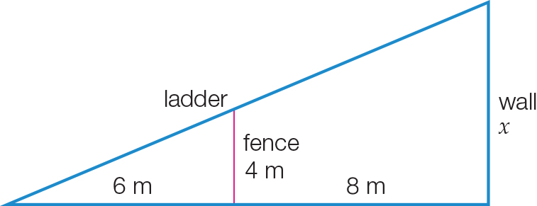

**(b)**



Therefore, the ladder is 9.3 m up the wall.

Extended answer total marks: 27

TOTAL test marks: 66